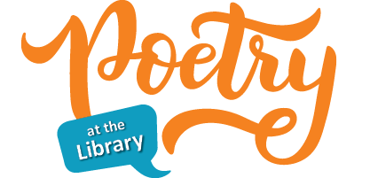

Earth Day and Easter aren’t the only holidays in April; it is also National Poetry Month. The Greenville Public Library will be celebrating by hosting a poetry contest. There will be three age groups: 3rd – 5th grade, 6th – 8th grade, and high school students.

The theme for our poetry contest is SPRING. Poems can be about anything associated with Spring. All entries need to be received no later than Saturday, April 23rd.

Age Groups:
3rd – 5th: up to 20 lines
6th – 8th: up to 20 lines
High School Students: up to 40 lines

The contest will be judged blind. Make sure your name does not appear on the page with your poem. Include the Permission to Publish form, which can be downloaded on our website or picked up at the library. Typed or hand written submissions will be accepted. We will not be returning poems, so make sure to send us a copy, not the original. Poems and Permission to Publish forms may be mailed, delivered to the library, or put in our drop box.

The best poems from 3rd-5th and 6th-8th will receive a $10 BOCO Bucks certificate. The best poem from the high school submissions will receive a $25 BOCO Bucks certificate. The library will post the winning poems on its website and Facebook page.

The contest will be judged by Hannah Marshall, who was an employee at the Greenville Public Library and is a published poet. She is also the poetry editor for the literary journal South 85. Her poem “This Is a Love Poem To Trees” was selected by former U.S. Poet Laureate Tracy K. Smith for The Best American Poetry 2021.

